Assignments

First:
Create the readme.md to understand the flow ,impacted file and apis for ingestion

Prompt:
Act as a expert senior software engineer and technical writer. Please generate a professional, well-structured, and comprehensive `README.md` file for my project.

### Project Details:
- **Project Name:** [e.g., TaskFlow]
- **One-Sentence Summary:** [e.g., A lightweight, real-time task management app built for remote dev teams.]
- **Tech Stack:** [e.g., React, Node.js, Express, PostgreSQL, Tailwind CSS]
- **Key Features:**
- [Feature 1: e.g., Real-time WebSocket updates]
- [Feature 2: e.g., OAuth2 authentication]
- [Feature 3: e.g., Customizable Kanban boards]
- **Prerequisites:** [e.g., Node.js v18+, Docker, PostgreSQL]
- **Environment Variables Needed:** [e.g., PORT, DATABASE_URL, JWT_SECRET]

---

### Instructions for the README Format:
Please format the `README.md` using clean Markdown with the following section structure:

1. **Header:** Title, catchy tagline, and badges (e.g., License, Build Status, Node Version placeholders).
2. **Table of Contents:** Quick jump links to each main section.
3. **About The Project:** A brief overview, including the problem it solves and a "Built With" section listing the main technologies/frameworks.
4. **Getting Started:** Clear step-by-step instructions on how to set up the project locally:
- **Prerequisites**
- **Installation & Setup** (including cloning, installing dependencies, and configuring `.env`)
5. **Usage:** Examples or commands on how to run the app (development, production, testing). Include code blocks for standard CLI commands.
6. **Configuration / Environment Variables:** A quick reference table for required `.env` variables.
7. **Roadmap / Future Improvements:** (List 2-3 bullet points for future planned features).
8. **Contributing:** Brief standard guidelines on how others can submit Pull Requests.
9. **License:** Mention [e.g., MIT License].
10. **Contact / Acknowledgments:** Brief section for author contact info or credits.

> **Note:** Use clear headings, code snippets for standard bash commands, concise bullet points, and helpful placeholders (e.g., `your-username/your-repo`) where details aren't provided.

VS Code:
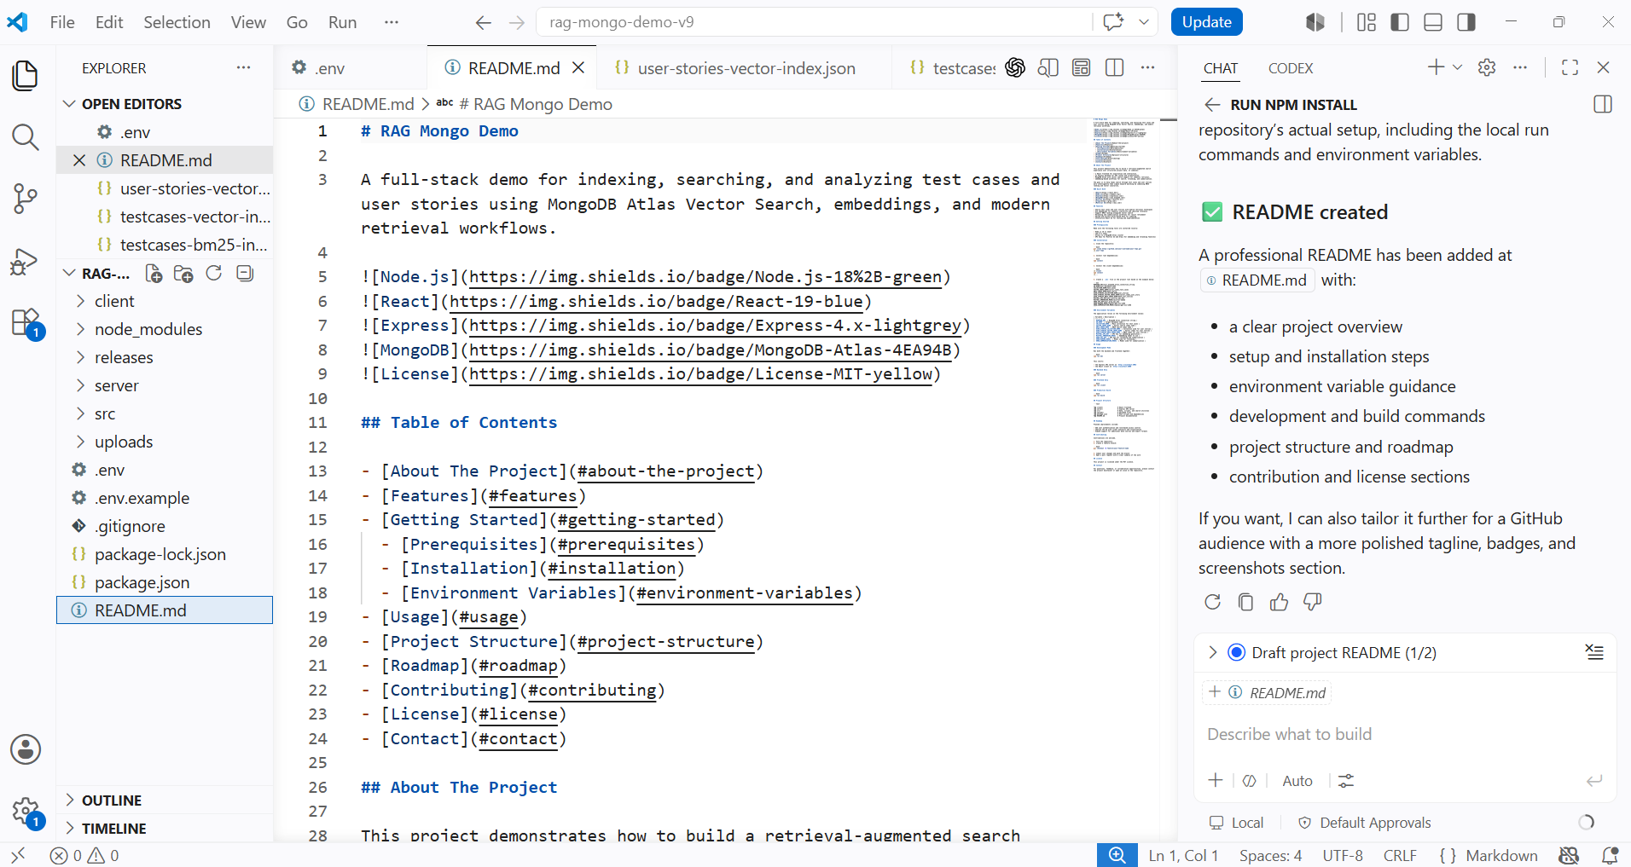

Second:
Explore embedding model
Cohere
Voyage
Jina
Login and create the api

Prompt:
Refer this url https://docs.cohere.com/reference/embed and generate a postman collections for all the API scenarios

Generated JSON:
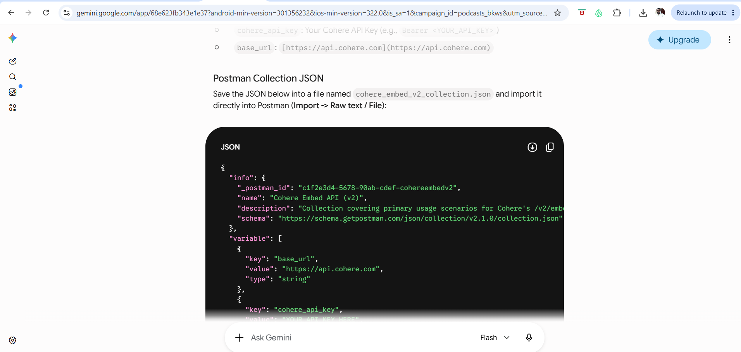

API:
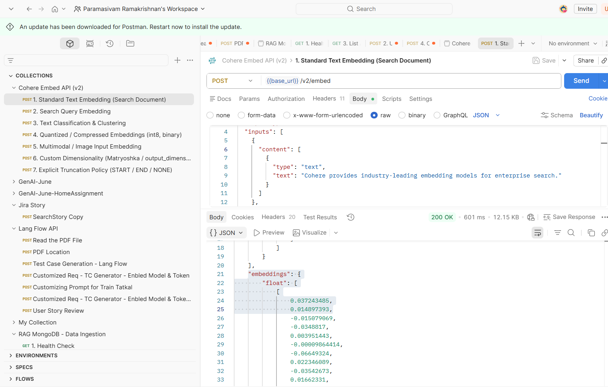

Class Room Session UI:
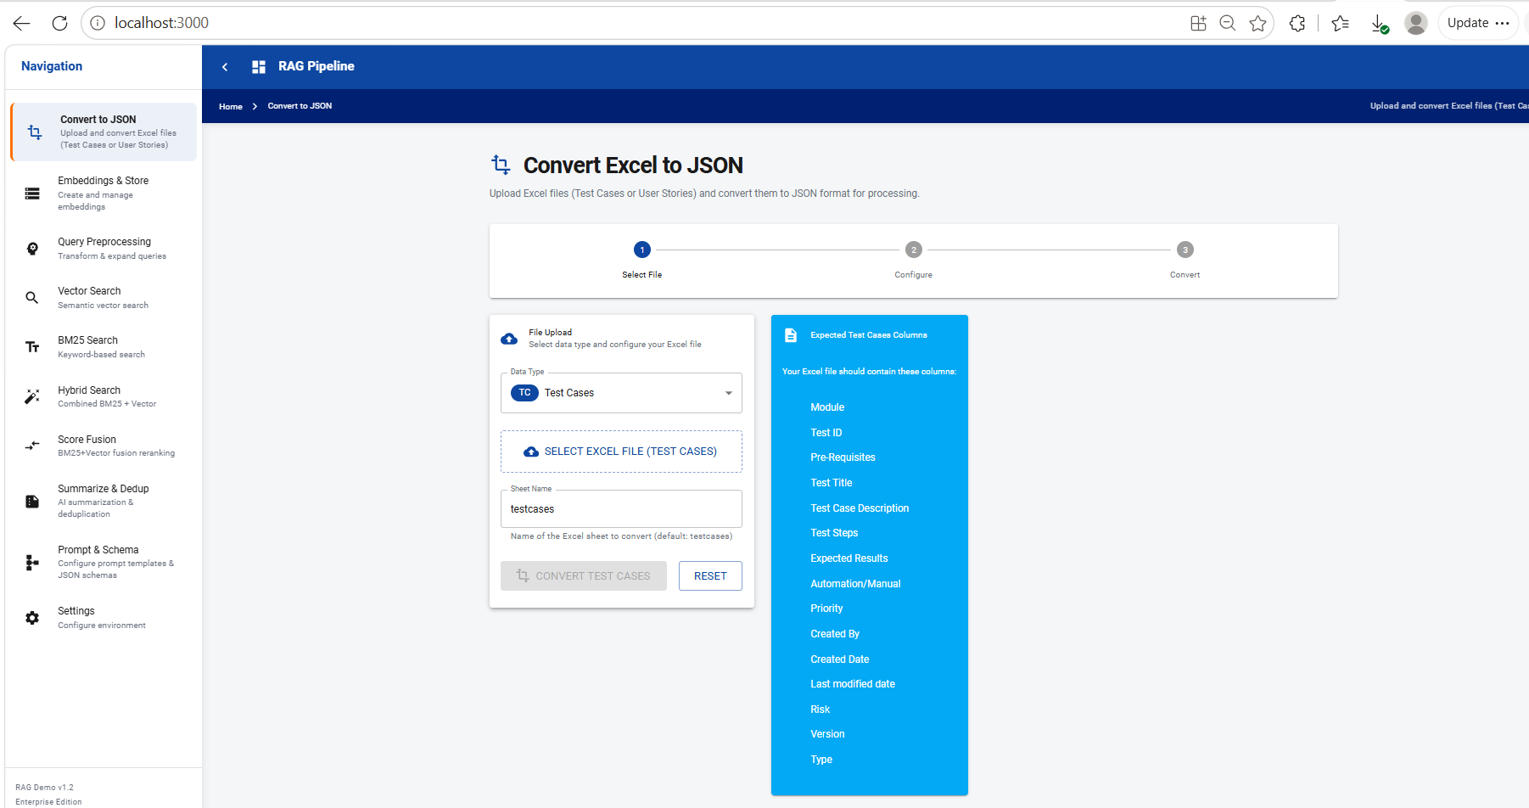

File Converted into JSON
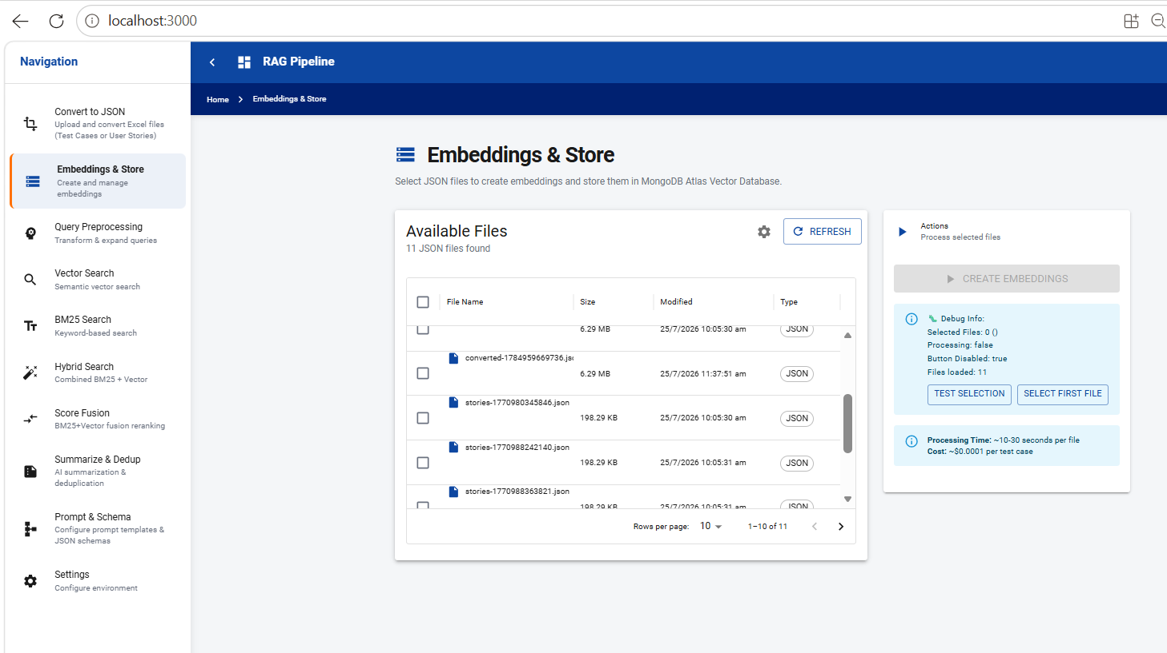

JSON Uploaded into Mongo DB for Test case
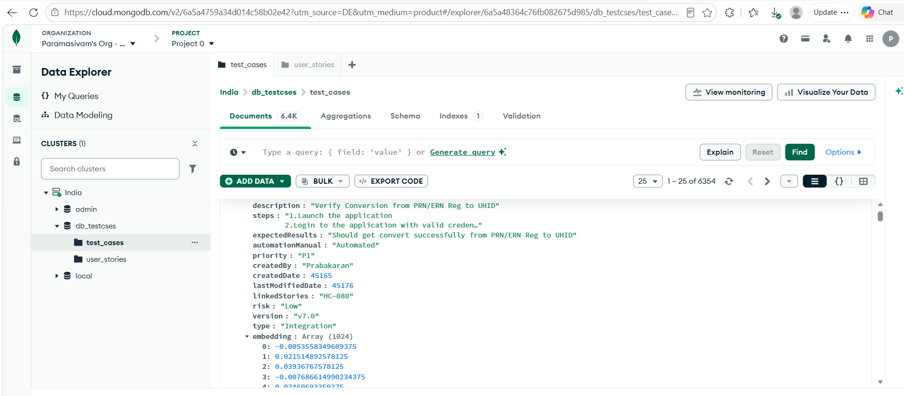

Class Room Session Postman API:

Upload Excel
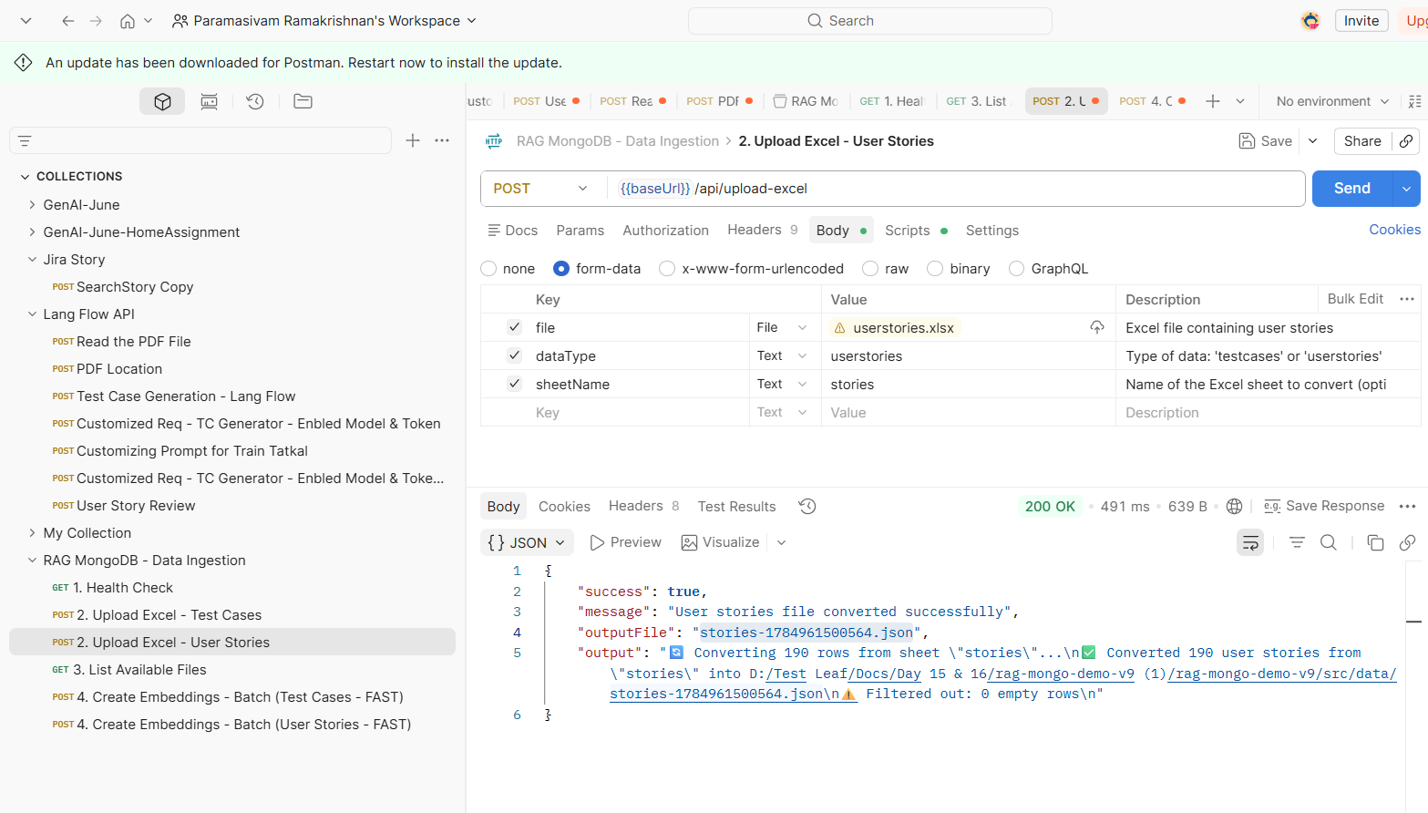

Embedded Created for User Story
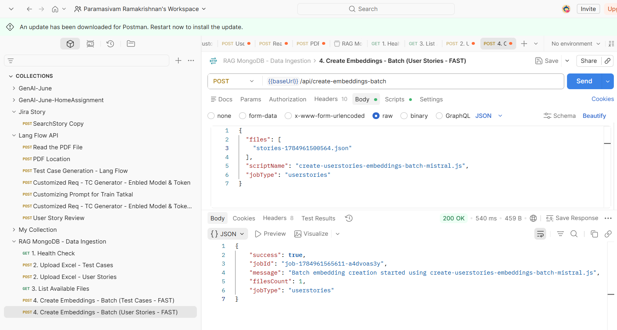

Uploaded in Mongo DB
